Coding from Excel to GoldVarb2001

Step 1. Preparing an Excel coding sheet

On the first line of the Excel sheet you are going to write the labels of your coding as you can see on Picture 1 below:
Picture 1: Excel work sheet
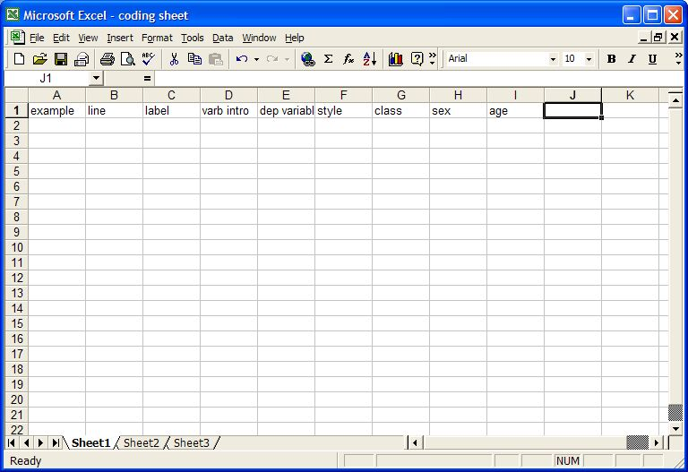

Once you have entered the labels of your coding sheet on the first line of the excel you are ready for Step 2.

Step 2: Creating a formula to group coded factors in one single cell.

In order to transfer your codes to GoldVarb 2001, you need to create a formula that will group all the factors coded per line in one single cell of your Excel sheet. This formula could be added to the last column of your Excel sheet. In the case of the example in picture 1 above, this column is “J”. The first line of column “J” will carry the label “Formula”. After clicking on “J2” (the second line of column “J”) you should type an equals sign: =. Then click on line 2 of the column that carries the first character of your coding string. In the case of the example given here, that column is “D”, and the cell to be clicked is “D2”. Once you have done that, your “J2” cell will read “D2”, as you can see in Picture 2 below.
Picture 2: Creating Formula
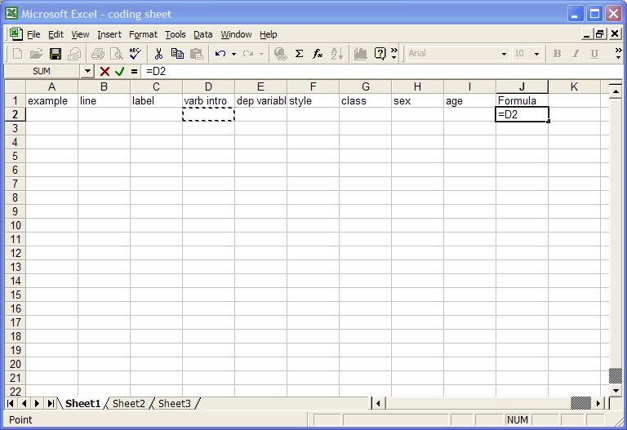
There will be a cursor blinking on the right side of “=D2” and you should now type &. Then proceed by clicking on the following column, here “E2” and adding &, until you have completed your formula.
In the example provided here, the coding string ranges from column D to I. So, the formula on “J2”, here, should read =D2&E2&F2&G2&H2&I2, as it can be seen in Picture 3 below.

Picture 3: Formula completed
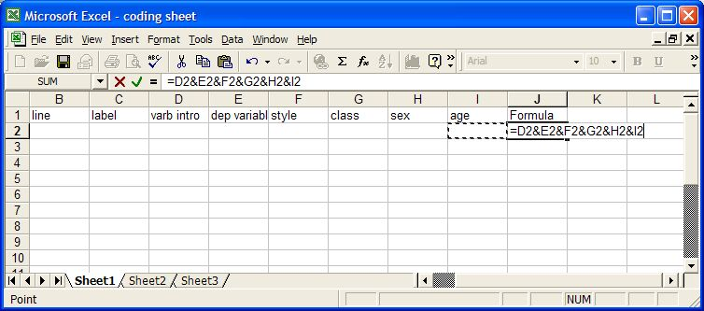

When you have completed writing your formula, you should click enter. In order for your formula to be effective throughout the entire column J, you will need to select that column from the line where the formula was written, to as far down on that column as you wish or need. After you have selected the column to as far down as you wish or need, you should click ctrl+D. This command will fill down the entire column with your formula, and you are ready to code.
As you code you will notice that the code will automatically appear on column J without space between the characters, as you can see on Picture 4 below.
Picture 4: Sample Code
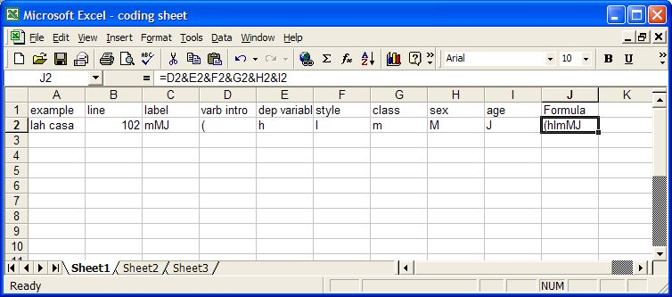

Step 3: Transferring your code to GoldVarb 2001.

Once you are done coding, you should select the entire column J, then click on copy (ctrl+C). Then open a word document and past your column J there. It will appear in the form of a table. You need to convert the table in text and then make sure your font is courier new.
To convert your table into text, click anywhere inside the table, then click on table (where you have file, edit, view, insert, format, tools, table, window, and help), select convert and chose the option table to text. Make sure your font is courier new and paste your text on your GoldVarb 2001 token file.

