Section 1. Coding
Open GoldVarb window.
Picture 1: GoldVarb 2001
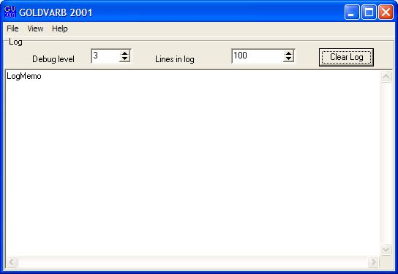
Click on view and select token.
Picture 2: Opening token file
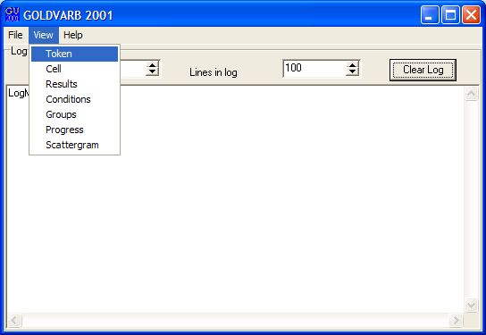

A token window will pop up.
Picture 3: Token file
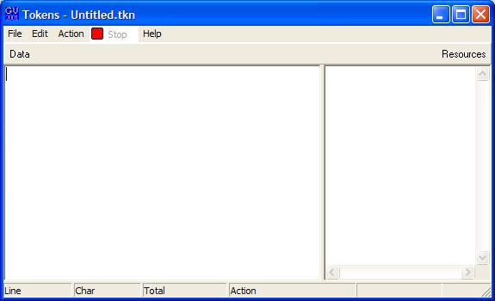
When the token window is open, click on file and then select save as in order to name your new token file.
Picture 4: Saving token file
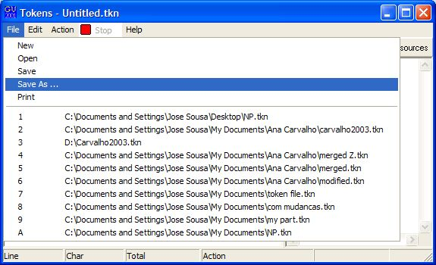

Name your token file and you will be ready to code. Remember to always save your changes before you close the token window. GoldVarb will not ask you if you want to save changes once you have click on close. If that ever happens or you have some kind of power outage your work will be lost. Saving your work every few minutes is the safest way to go.
Section 2. Checking tokens
Tokens should be checked for errors after they are coded. In order to check tokens for errors, the token file to be checked must be open. And the factors must have been entered in the factor groups. There are two ways to enter the factors: manually and by scanning the token file. Manual entry of factors in their respective groups is extremely recommended at this point for there may be errors in the token file. Scanning tokens at this point will cause coding errors to be counted as a factor in the coding string.
In order to enter the factors in their respective groups, the token file you are working with must be open. Click on groups as shown in Picture 5 below from the main Goldvarb window.
Picture 5: Selecting groups
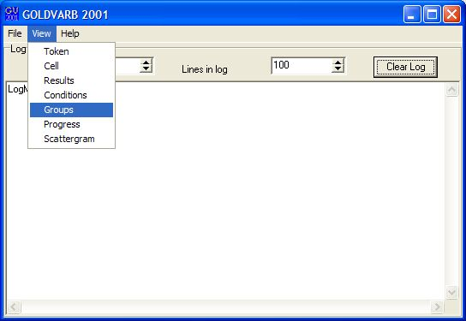
After clicking on groups a window named groups will open. That window will first look like the one in Picture 6 below:
Picture 6: Groups
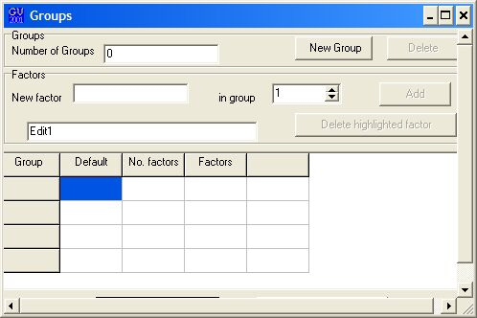

Note from Picture 6 (above) that there is a column where the factors should appear. In order to enter the factors you must click on new groups and then click on the square right under factors in order to highlight it. After the factor square is highlighted you click on the entry space that reads new factor. It is on that space that you should enter your new factors and then click “add”. After clicking “add” the factors will appear in the square under factors. The number of factors will automatically be indicated but you must highlight the square under default in order to enter the default factor for each factor group. That default factor is the first code from the codes entered for that group. After the default square is highlighted and the default factor has been entered you must click back on “new factor”, enter the same default code and then click “add”. After that has been done you can click on “new group” and follow the same procedure for the next group of factors. When all the factors have been entered your group window must look like the one in Picture 7 below. Make sure you click on “save to token files” and then “OK”, in order to save your entries.

Picture 7: Groups completed

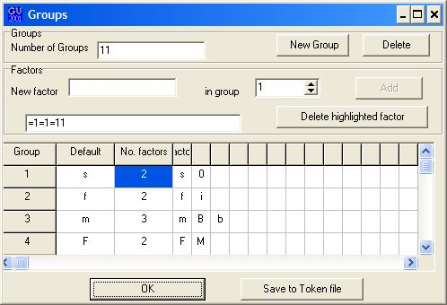

After the factors have been entered and saved to the token file, they will appear on the right side of your token file as in Picture 8. Now you are ready to check your tokens for errors. From the token file window click on “action” and then “check tokens”, as it can be seen in Picture 8 below.
Picture 8: Check tokens
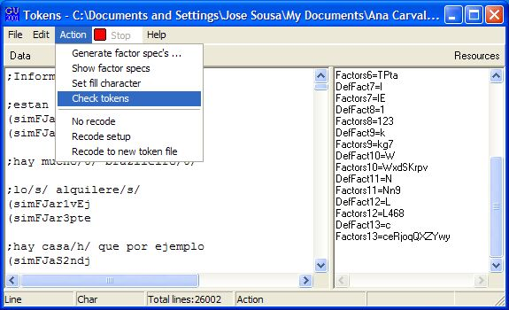

When the “check tokens” task finds an error, that error will be displayed in the main Varbrul window like the one below.
Picture 9: Error

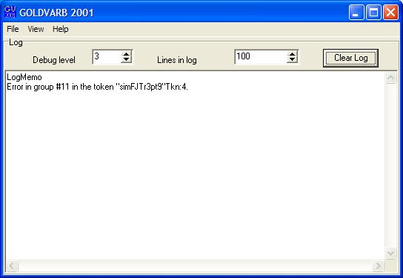

Note that the group in which the error occurred is indicated for better visualization. Varbrul will also give you the token and its number, so you can find it and fix the error. In order to find a token you need to highlight the token indicated, then copy and paste it into the “go to/find” window. To get to the “go to/find” window, you must click on “edit” on the token file window and then “go to/find”, as in Picture 10.

Picture 10: Edit
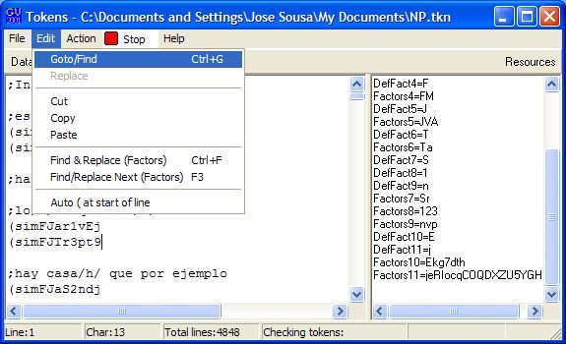

When you click on “go to/ find” a window named “go to/find” will open and you should paste the token you have copied into the area named “find text”, then click “find” (Picture 11). Varbrul will scan the file and will show you a highlighted token which should be the one you are looking for (Picture 12).

Picture 11: Go to/ find window
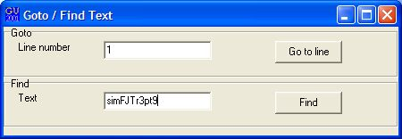

Picture 12: Token found
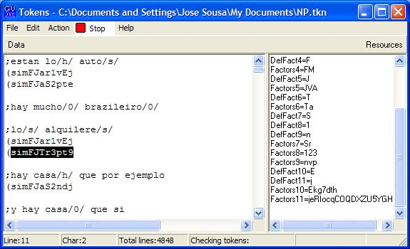

In the token found in Picture 12 the code “9” in group 11 should be “e”. After you have made the corrections you take the same procedure of checking tokens until the main window of Varbrul tells you that all the tokens have been checked. It will then give you the number of tokens you have in your token file. After all tokens have been checked you are ready to run the results for your sample.

It is important to be aware that sometimes times Varbrul does not act “case sensitive”, that means it will not recognize the difference between an “E” and “e”. I will find the error, if you have one instead of the other and will display the token containing that error in the main window, however, the “case sensitive” problem may occur when you use the “go to/ find” task. Varbrul might show you a token that is not the one you are looking for. When that happens, you should keep clicking on “find” from the “go to/ find” window until you have found the token you are looking for. You might find it useful to use the command “ctrl + G” follow by “enter” to save you some time.

Section 3. Running results
When you are ready to run your results you should click on “action” from the token file window and then “no recode” (Picture 13). That if you do not need to create conditions for your sample (for creating conditions see Excluding Factors on Section 4).
Picture 13 No recode
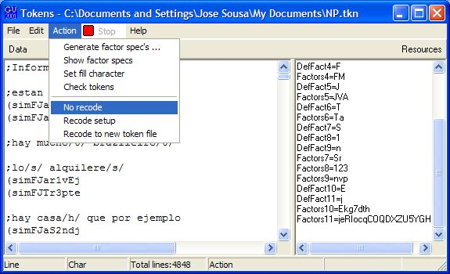

Once you have clicked on “no recode”, go to the main window and click on “view” and then on “results” (Picture 14).

Picture 14: Results
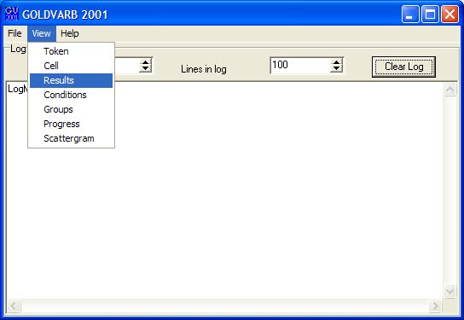

When you have clicked on “results” a new window by the same name will open. From the results window you should click on “action” and then on “load cells to memory” (Picture 15). When you have done that a new window named “conditions” will appear together with a small window called “application values”, with your dependent variables in it. For the present study the dependent variable are “s” and “0”. Once your dependent variables have appeared in the application values window you must click OK. A new window named “cells” will open, and on top of it the “results” window will reappear with the frequencies for this run. You can save your frequencies into a Word document using the “copy and paste” task. From that same results window you may ask Varbrul to run a “Binominal up and down” and/or a “Binominal one level” analysis by clicking on “action” and then selecting the respective kind of analysis you want to run.

Picture 15: Load cells to memory
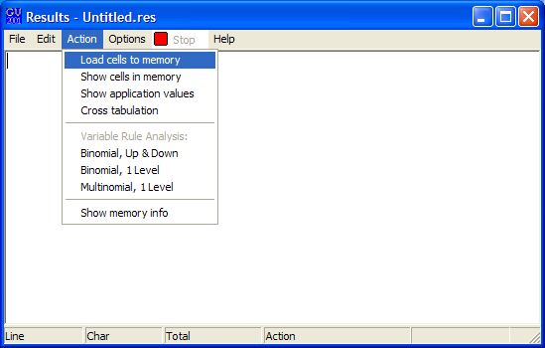

Section 4: Recoding
Some times you may find “knockouts” or “singletons” on your first results window with the frequencies for your sample. When that happens you cannot proceed to run a Binominal analysis. You must first recode your token file in order to proceed to a Binominal analysis.
In the study used to illustrate these procedures “knockouts” were found for the last group of factors. In order to eliminate those knockouts from the analysis the sample some of the factors needed to be recoded. The recoding of these factors was done by merging the factors that were in knockout into factors that were not in knockout. Here the factors in knockout were “C”, “c”, “Q”, “G”, and “H”. The following decision was made: “c”, “Q”, and “G” would be coded as “R” and “C” and “H” as “e”. In order to do so the task “Find and replace (Factors)” was used.
To use the “Find and replace (Factors)” task you must click on “edit” from your token file and then “find and replace (factors)” (see Picture 16).

Picture 16: Find and replace (factors)
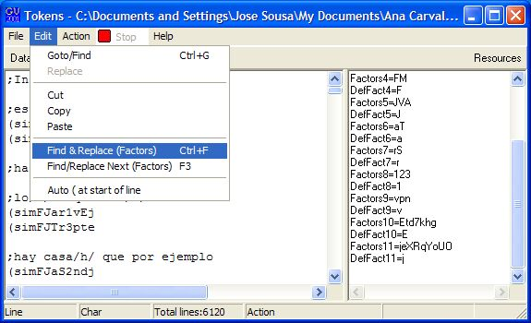

Once you have selected the “find and replace (factors)” option a window by the same name will appear (see Picture 17). This window is divided in two areas. One where you find the factors you are looking to recode. You select them by browsing the groups clicking on the arrows on the upper left side of the window. And the other area is the one in which you select the group you looking to make a change and then type in the new code (see Picture 18).

Picture 17: Find and replace window
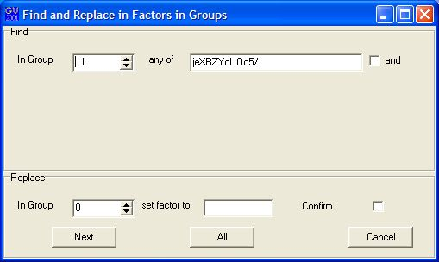

Picture 18: Replace code
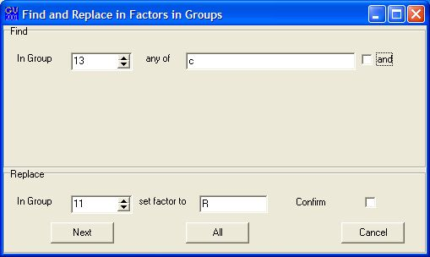
Once you have chosen the code you want to be replaced and typed in the code you want to replace, you can either click on “next” or “all” to make the replacement. If you click on “next”, Varbrul will show you which token is being recoded, however, if you click on “all”, all the tokens with the code “c” (in the case of this illustration) will be substituted by “R” and you will not know which tokens were actually recoded.
Another way to eliminate knockouts from your sample is by creating a condition file excluding factors. That is explained in the section 4 below.

Section 5: Excluding Factors.
There are two ways you can exclude factors from your analysis. One is by using the task “recode” from your token file, and the other is by writing a syntax command in the conditions window. In order to use the “recode” task, from your token file click on “action” and select the option “recode setup” (see Picture 19).

Picture 19: Recode setup
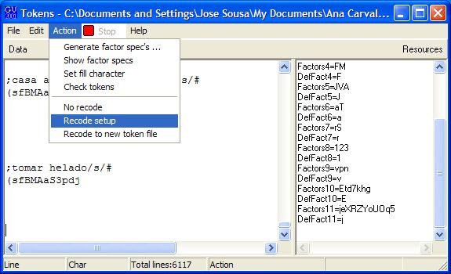
Once you have selected the “recode setup” option a window named “recode definition” will appear (Picture 20). You should click on “exclude” and then select the factor or factors you want to exclude from your analysis. Then you must click on “modify”, followed by “finish current operation”, and finally click on “OK – write new conditions from recode instructions”. Once you have done all that, you can go directly to the main window, click on “view” and then select “results” (Picture 14), and from the “results” window you can click on “action” and then “load cells to memory” (Picture 15). When you are done and have confirmed your dependent variables, the “conditions” window will appear with a syntax command excluding the factors you wish to exclude from the analysis. Your “conditions” window will look like the one in picture (21).
Picture 20: Recode definition
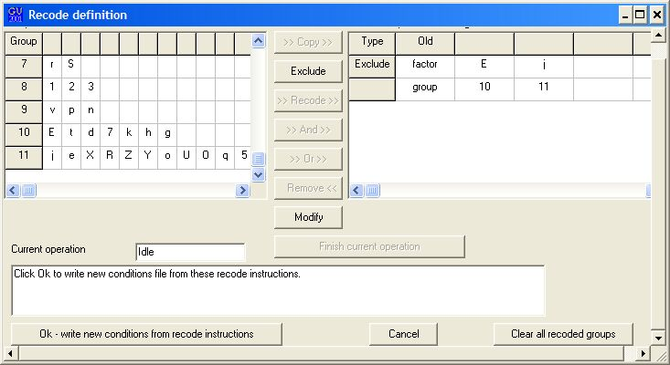

Picture 21: Conditions
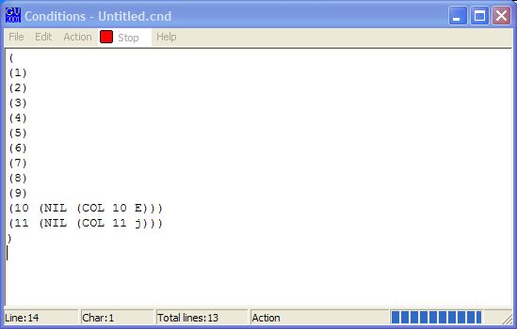
You may also chose to go to the main window and click on “view” then select “conditions”. The same window you see in Picture 21 will appear, and you can type in the command for exclusion of factors according to the example you see in Picture 21.

