Student Financial Aid

Enrollment Management Computer Based Training

Date Issued/Rev: 12/15/2008
General Description: This procedure explains what steps are needed to complete the Enrollment.
Responsible Manager: Financial Aid Director
Related References:
Related Procedures:
Related Websites: http://my.unm.edu
Please note - All material will be provided by links from the Employee Life tab once you have logged into the website.

There are four trainings:
EM 101 – Overview of Enrollment Management (Search: Enrollment)
EM 102 – Introduction to Admission (Search: Admissions)
EM 103 – Introduction to Financial Aid (Search: Financial Aid)
EM 104 – Introduction to Records and Registration (Search: Records)

PROCEDURE

Step 1 – Loggin to My UNM at http://my.unm.edu using your UNM Net ID and password.

Note - Pop-up blocker will need to be disabled.

Step 2 - Click on the “Employee Life” tab in the My UNM web page.

Step 3 – Look to the lower right side of the Employee Life page.

Step 4 - Select the ‘Learning Central’ option from the Banner Training section. Please refer to Figure 1.

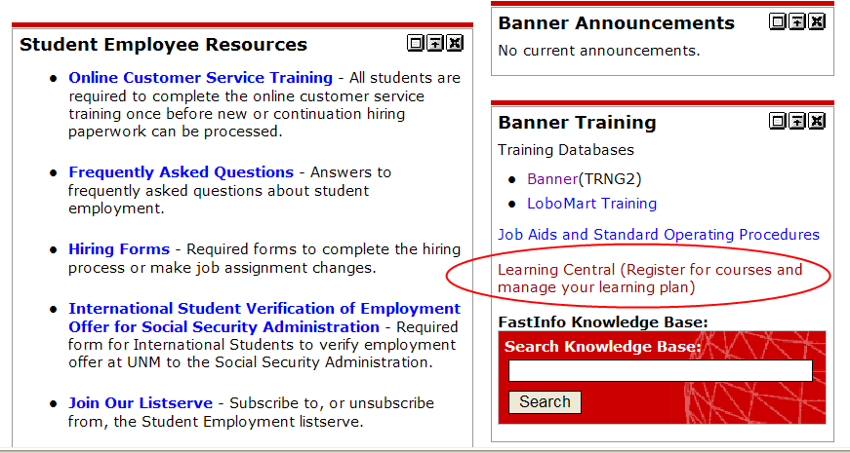
Figure 1 – Link to Learning Central
Step 1 - Login at the upper right in the Learning Central webpage. Please refer to Figure 2.
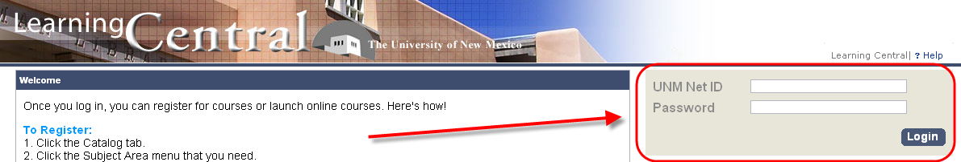
Figure 2 – Learning Central login page
Please Note - All new hires should be able to access learning central with their UNM Net ID and password. If you have a UNM Net ID, and it has been 24 hours since you created it and you still cannot access Learning Central please speak with the Human Resources department at 277-6947.
Step 3 - Verify that your Personal Profile information is correct once you have gained access to Learning Central. This information will be in the top left hand corner of your screen.
Step 4 - Click on the 'View all available online items’ link
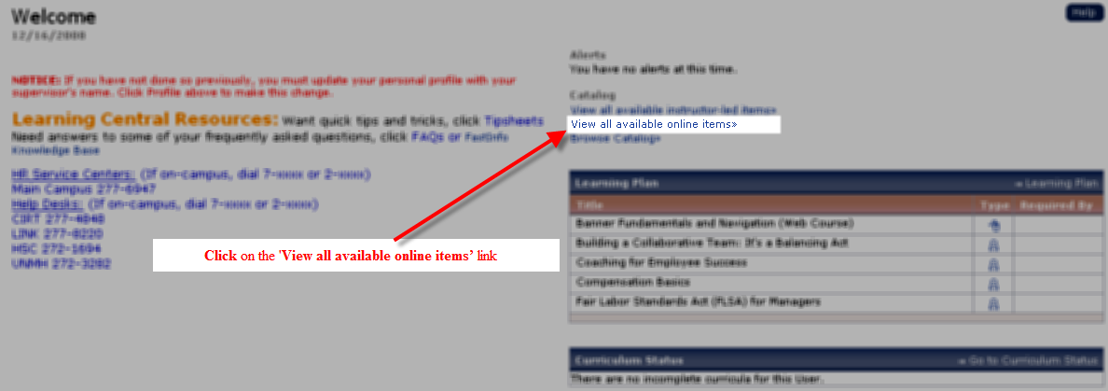
Step 5 – in the Keywords field enter the training name you are looking for.
i.e. for the Introduction to Admissions – enter Admissions
Click ‘Search’
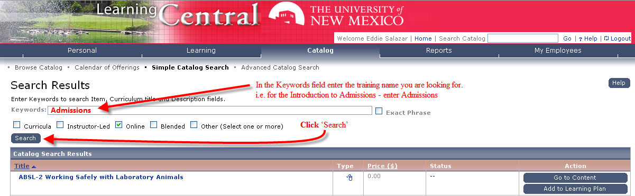
Step 6 – The search results will bring back the required training -
Click ‘Go to Content;
Step 7 – Click ‘Introduction to….(Online Course) to begin the PowerPoint training.
Step 8 – Once the you have completed the PowerPoint – you can access the test. Once the Test is completed for each module, it will be added to your Learner Record.
***Repeat Step 4 through Step 8 for each remaining training.
***A score of 90% or better on EM 102, 103 and 104 must be scored on the test for completion.
***EM 101 does not have a test.
There are four trainings:
EM 101 – Overview of Enrollment Management (Search: Enrollment)
EM 102 – Introduction to Admission (Search: Admissions)
EM 103 – Introduction to Financial Aid (Search: Financial Aid)
EM 104 – Introduction to Records and Registration (Search: Records)

