 | LINK Financial Aid | 

FA-102 Consortium Agreements

Date Issued/Rev: 11/03/05
General Description: This procedure explains how to log on Consortium Agreements.
Responsible Manager: Financial Aid Director
Related Procedures:
Related Forms: RBAABUD
ROAENRL
RRAAREQ
RHACOMM

PROCEDURE
Procedure:
1. Verify that the Consortium Agreement is complete
- Consortium Agreement form has been completed by Host Financial Aid Office and UNM Academic Advisor
- Copy of enrollment at host school
- Copy of payment at host school
2. Go to RRAAREQ
3. Insert record
4. Type appropriate Consortium Agreement mnemonic (ex CSORTF, CSORTS, CSORTX) in new record.
5. If Consortium Agreement is complete enter “C” in status code
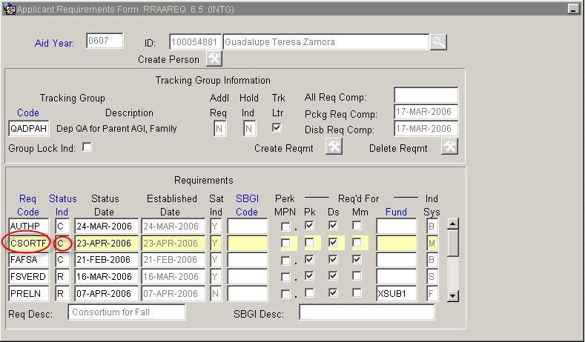
6. If Consortium Agreement is incomplete enter “I” (for ‘received incomplete’ status).
- Save and Exit
- Go to ROAMESG
- Perform “Next block”
- Tab to “Date” field (leave Message Code field blank)
- Enter date you want message to expire
- Enter your message explaining why consortium is incomplete
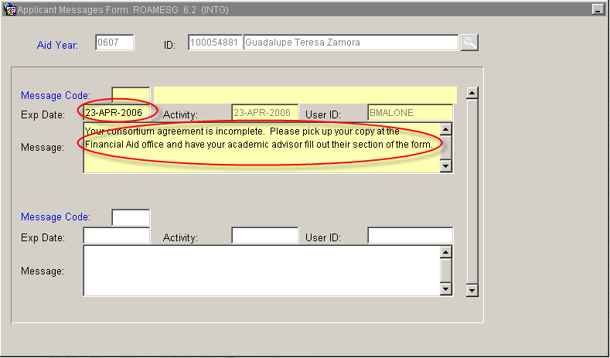
- Save and Exit
7. Go to RBAABUD
8. Perform “Next block”
9. Insert Record
10. Enter appropriate Consortium Agreement tuition component (FCSO, SCSO, XCSO) and amount (see FABU-107)
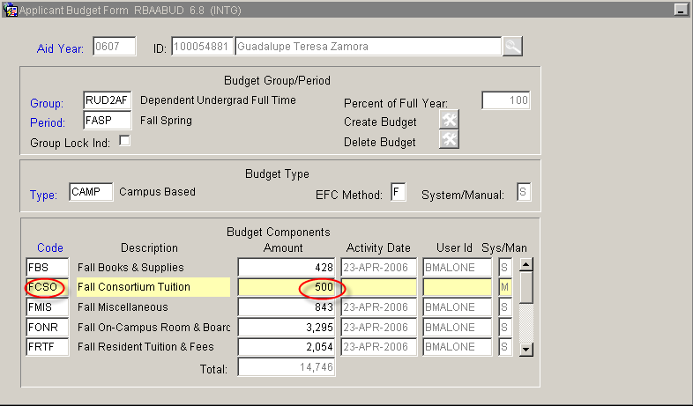
11. Reduce UNM tuition, if applicable.
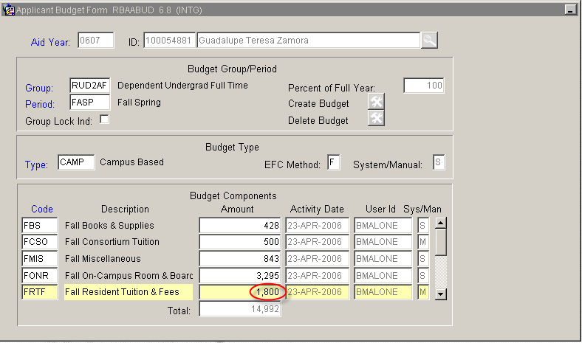12. Save and Exit
13. Go to ROAENRL
14. Perform “Next block”
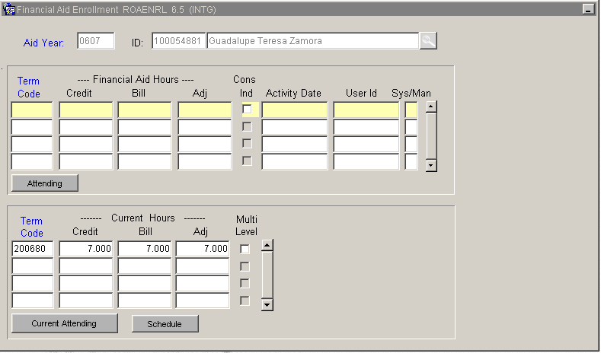
15. Enter term code under Financial Aid Hours section (ex: 200680, 200710, 200760)
16. Tab over to Credit, Bill, and Adj fields and enter the total number of hours the student is expected to be enrolled in at UNM and the Host school (so if student is registered for 7 hours at UNM and 6 hours at TVI enter 13 in each field)
17. Click in CONS IND field, so that check mark appears
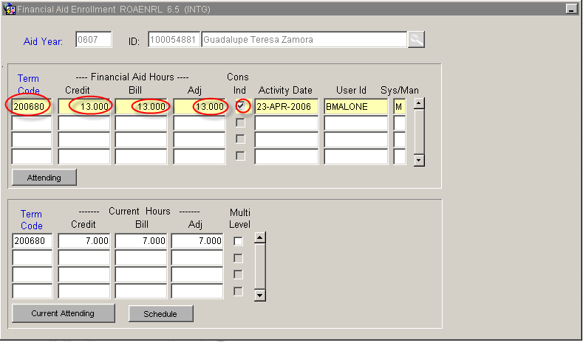
18. Save and Exit
19. Go to RHACOMM
20. Leave note that should include:
- Host school name
- Hours at host school, including course numbers
- Expectation that future aid will not be released without receipt of grades from students at the end of the term
21. Save and Exit

***Note: A mnemonic will be batch posted at the end of the term that will generate an MIL message that will request the grades for the term. This mnemonic will hold disbursements until it is satisfied.
* * * E N D * * *

