-ROARMAN-
Financial Aid Summary Form
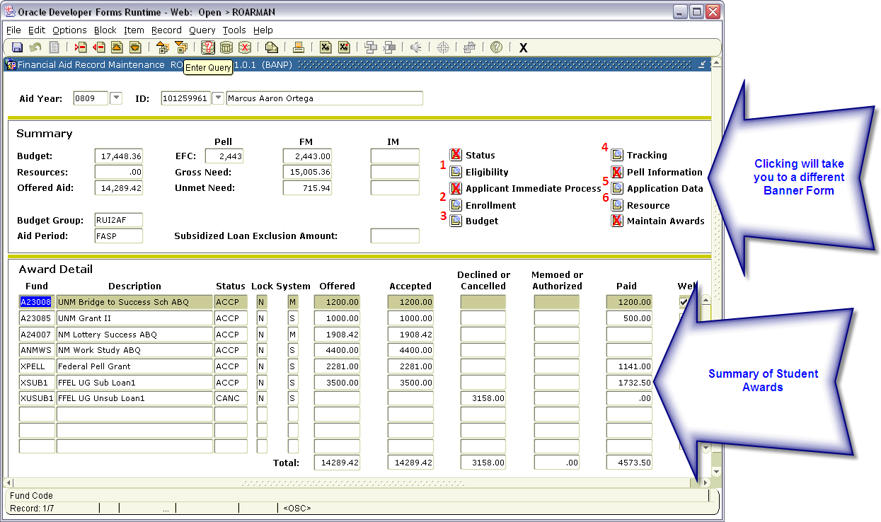
“1 Eligibility” – View Student’s SAP Status and Admissions Level Detail “4 Tracking” – View what documents are needed to complete file
“2 Enrollment” - View Student’s Enrollment for the Current Financial Aid Year “5 Application” – View Student’s FAFSA data
“3 Budget” – View Student’s Cost of Attendance “6 Resource” – View any Tuition Payments or VA Benefits for student

