Student Financial Aid

FAFM – 107 Return of Title IV Funds, Unofficial W/D (UW)

Date Issued/Rev: 6/4/09
General Description: This procedure explains how to process Return of Title IV Funds for students who unofficially w/d (UW).
Responsible Manager: Financial Aid Director
Related Procedures: FAFM - 103 Return of Title IV Funds, Official W/D (OW)
Related Forms: RPRTIVC, SHATERM, SHATCKN, SFRNOWD

General Remarks:
- UW’s occur when students don’t officially drop all their classes and receive all non-passing grades, or NR grades, or a combo of both. This can be confirmed on SHATERM, 3rd block, after grades roll.
- The process in a nutshell: UW’s are rounded up & herded to IT where they get branded with an official w/d date. They are then processed the same way OW’s are.
- If a student drops all classes except correspondence course(s) that are not expected to be complete before the end of the semester the form was completed, student is considered an OW W/D. Use w/d date from all other classes as Official W/D date & calc. R2t4. We CANNOT fund correspondence courses that will not be completed during the term. In order for a student to receive financial aid for correspondence courses, the correspondence course form MUST indicate they expect to complete the course(s) no later than the end of the term for which they're completing the form.
- The latest date aid may reinstated is 180 days after the end of the term. (Ex. Aid is canceled because Fall grade is NR. May reinstate aid if grade turns into passing grade, but only up until 180 after the end of Fall.) After that, t4 aid cannot be reinstated per Dept. of Ed.
- Fed. regs. state UW’s must be identified & a w/d date determined within “30 calendar days from the end of the payment period” (semester). Regs. also state, “A school must always return any unearned Title IV funds it is responsible for returning within 45 days of the date the school determined the student withdrew,”. Once the semester ends, the 30 day clock to determine a w/d date starts. Once a w/d date is determined, the 45 day clock starts & the unearned funds must be returned before it runs out. Many students with t4 aid will not have had all their grades posted by their instructors by this time. This effectively splits the UW’s into 2 groups;

A) Identified in step 2) of this procedure, this group includes only students who have had all
and only non-passing grades posted by their instructors when Records & registration rolls grades (i.e. no grades of “NR”). A file of these students is sent to IT immediately after grades are rolled because there is no reason to wait.

B) Identified in step 12), this group is all remaining potential UW’s for the semester. We wait
as long as we can before sending this file to IT because some of these are not UW’s. The
problem is they are indistinguishable from “real” UW’s. This unfortunate group of students
did not have all their grades posted by their instructors when Rec. & Reg. rolled grades. As a
result, they now have at least 1 grade of “NR”. Some have all grades of “NR”. This second,
very unfortunate group, will have all their aid canceled because their LDA will be 1 day prior
to the beginning of the semester. The point is “NR” grades must be considered non-passing
for r2t4 purposes, but may turn into passing grades at almost any time. Once a “NR” grade
turns into a passing grade, the student is no longer considered a UW and all t4 aid must be re-
awarded.

- For each student, the following has already been done before the file is sent to IT,
* Confirmed that student earned no credit.
* Each non-passed class is assigned a LDA using the following process;
each non-passing grade is looked at and the following determination made;
- If the grade is “NR”, LDA for that class is 1 day prior to the beginning of the semester
(IT does this)
- If the grade is any other non-passing grade, the LDA assigned to that class is supplied by
the instructor.
* The latest of these LDA’s is assigned to the student as his/her effective w/d date, also
called unofficial w/d date. (IT does this)
* The student is now processed using the same procedures used for an official w/d (OW).

** For unofficial w/d’s
Put “UNOF” message on ROAMESG, “semester code” in message field.
Example: SHATERM for unofficial w/d.
Note Passed Hours, Earned Hours and GPA Hours are all 0
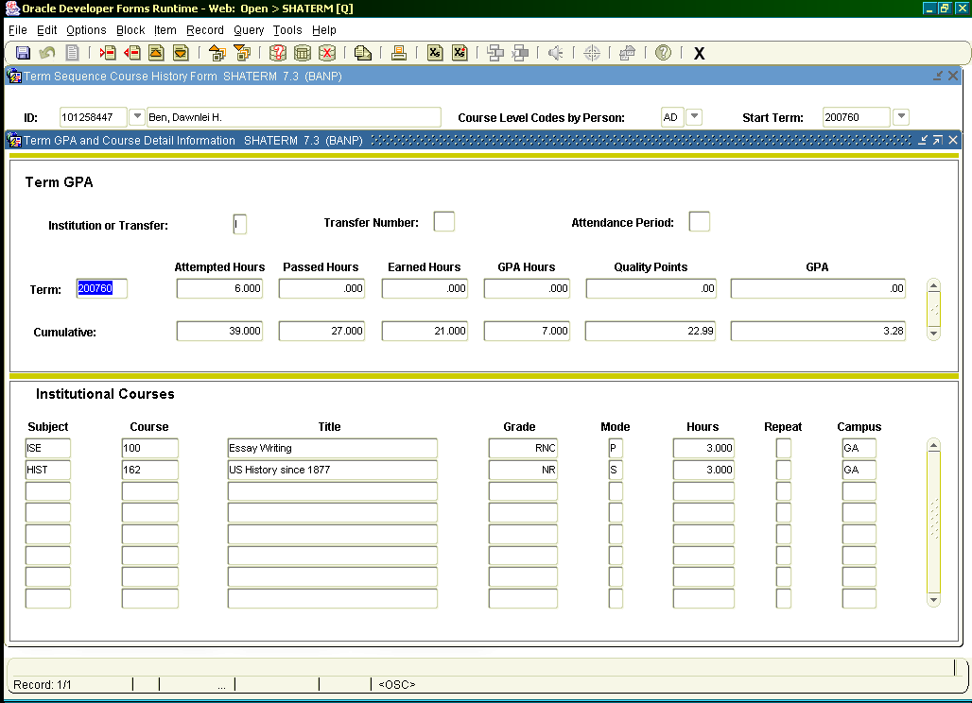

1. Run SFRNOWD (see end for parameters) without line “ 08 Grade which reflects drop = NR”
approximately 6 days after last day of finals to get idea of #’s. -- Shift F6 to remove a line --
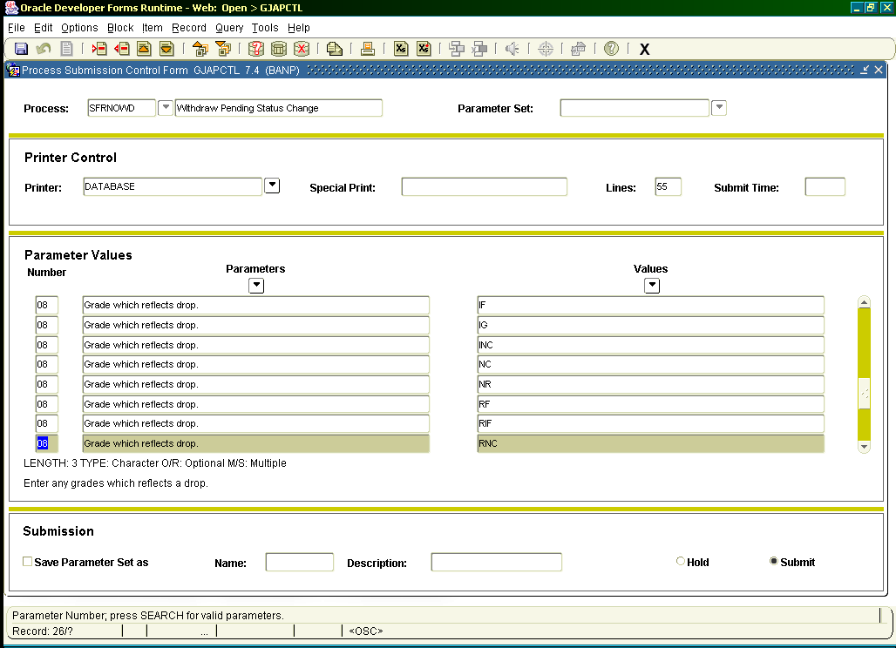
Remove this line for steps 1) & 2)

2. Run SFRNOWD (again without line 08 …) after grades are loaded (also called “rolled”) by Records
& Registration (approximately 1 week after last day of finals). -- Shift F6 to remove a line --

Print a hard copy if desired.

Review “Students Eligible to Enroll who have no Active Registration” section (if any) and cancel aid
if necessary. If student never enrolled, or w/d before term began, they are not eligible for t4 aid. See
FAFM-103, General Remarks section, “W/D before term began”.

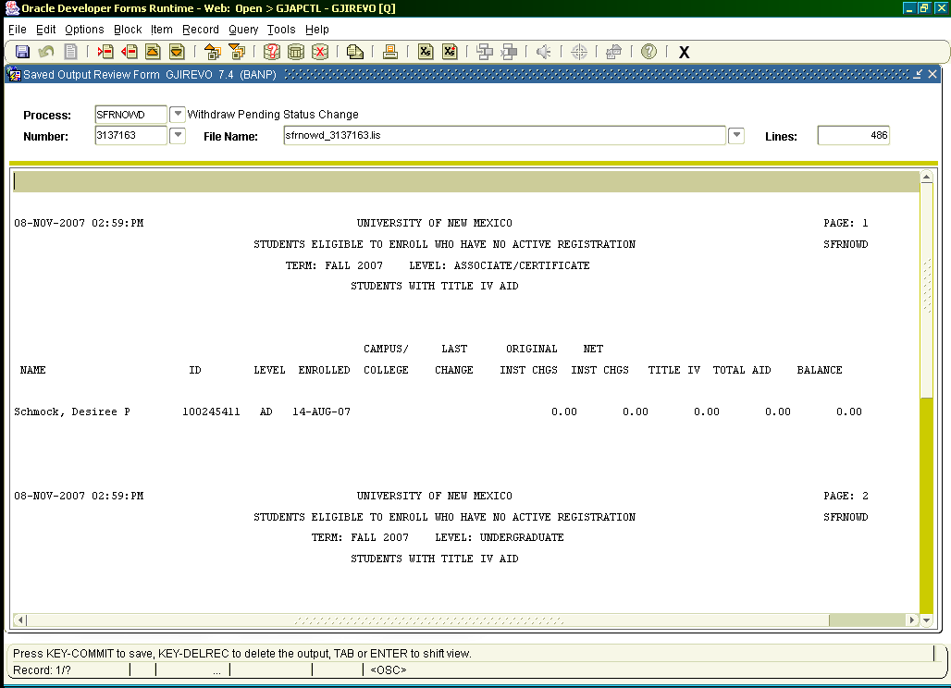

3. Show file in a browser.
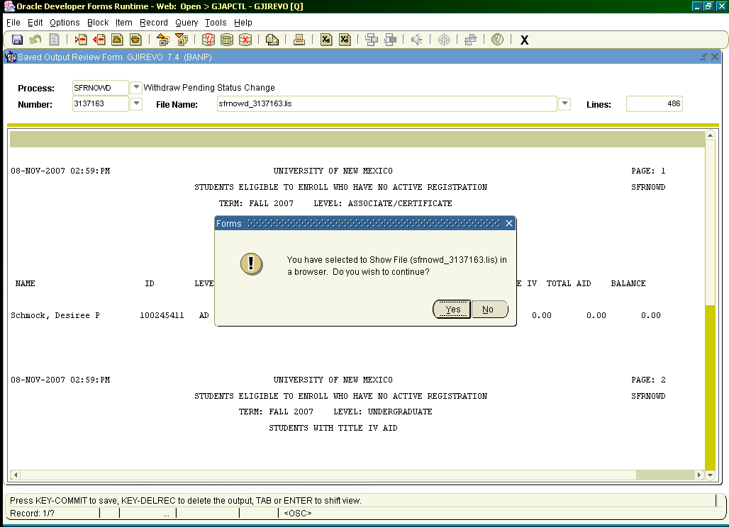

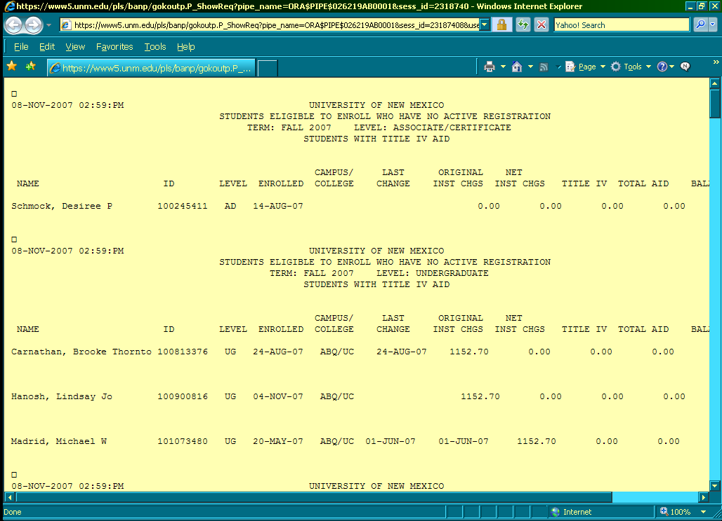
4. Save browser copy as text file.
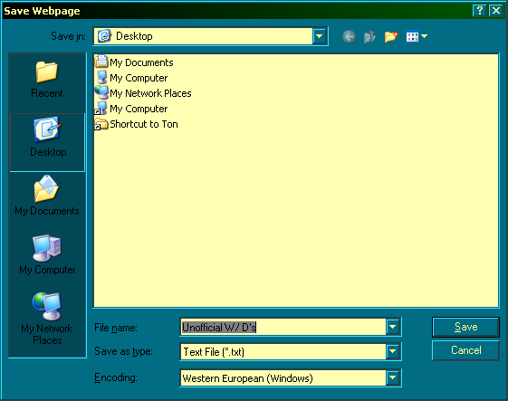
5. Open Excel. Import text file into Excel.
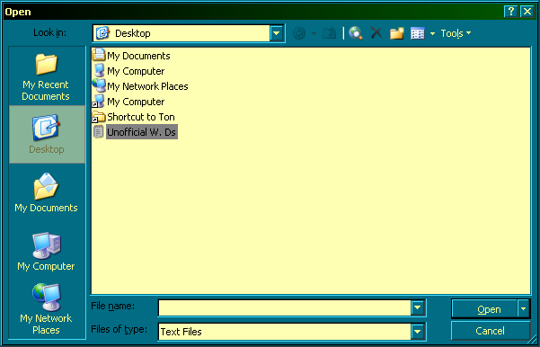

6. Highlight column “E”. Format cells, number, no decimals.
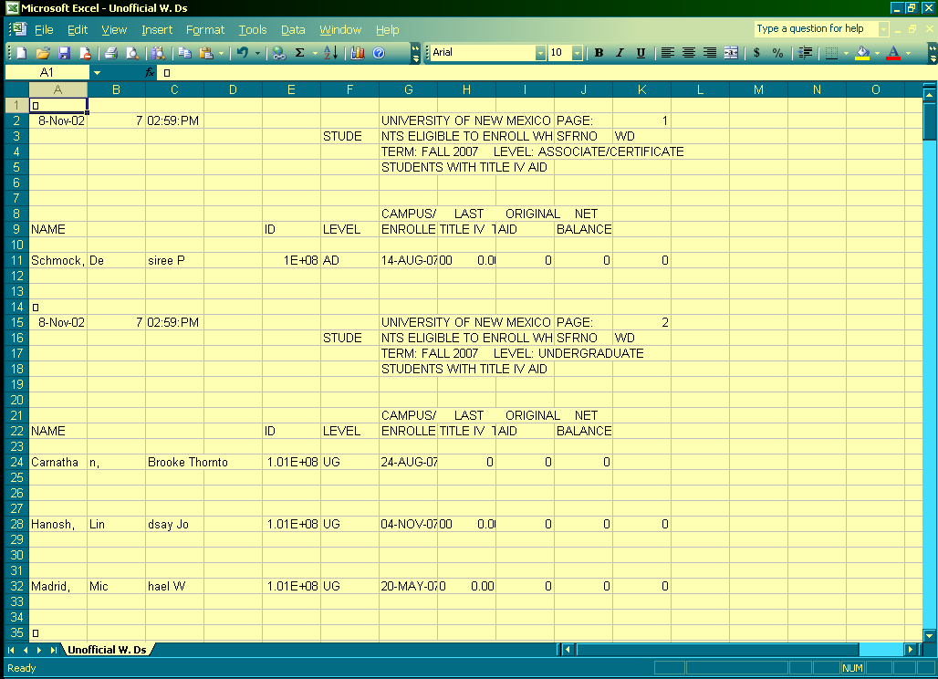
This allows you to see student ID’s.
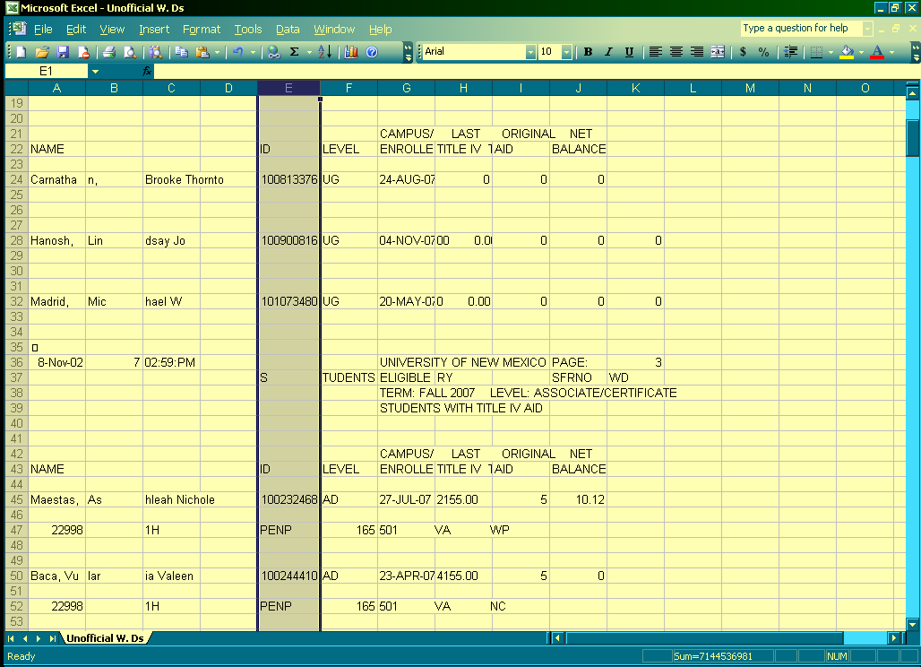
7. Arrange list of id’s (delete duplicates/not real unof – no t4 aid, no enrollment)
8. Make sure “Total of Students Processed” number on SFRNOWD matches total # on Excel file.
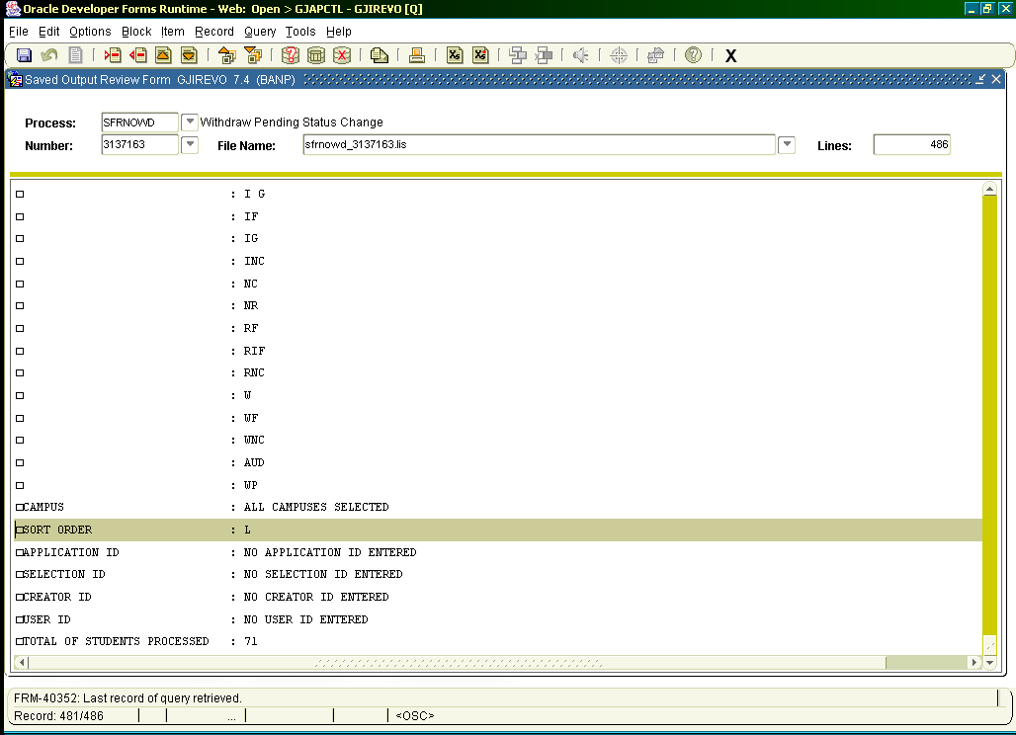
9. Email Excel file to our IT team, (Finaid-Tech-L@list.unm.edu).
10. For students with no passed or earned hours and Last Dates of Attendance (LDA)’s, unofficial w/d records . with effective w/d dates will be created in banner.
11. Run RPRTIVC and follow FAFM-103 R2T4, Official W/D (OW). In effect, these students are now treated . like official w/d’s.
12. Re-run SFRNOWD with line “08 Grade which reflects drop = NR” after approximately 30 days to include students whose grades have been posted late and students whose grades have not been reported. . Save Browser copy, import, etc. Run RPRTIVC and follow official w/d procedures. Check SHATERM . to confirm students didn’t earn any passing grades.

13. For grades that were “NR” and now have been updated by manual grade change, check SHATCKN (course . detail, comments field) for LDA’s.
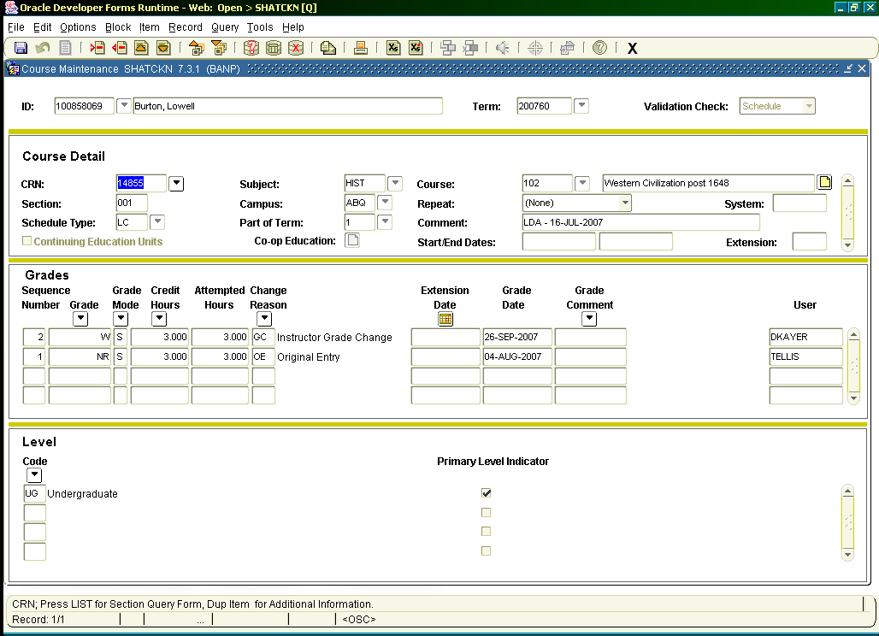

* * * E N D * * *

SFRNOWD parameters; F6 to insert a new line

01 Term code = 200680
02 Student Level = GR
02 Student Level = LW
02 Student Level = MD
02 Student Level = NG
02 Student Level = PH
02 Student Level = UG
02 Student Level = NU
02 Student Level = AD
03 Financial Aid Selection = T (Title IV recipients only)
04 Verify Enrollment = Y
05 Start Date = null
06 End Date = null
07 Verify History = Y
08 Grade which reflects drop = F
08 Grade which reflects drop = F G
08 Grade which reflects drop = I
08 Grade which reflects drop = I G
08 Grade which reflects drop = IF
08 Grade which reflects drop = IG
08 Grade which reflects drop = INC
08 Grade which reflects drop = NC
08 Grade which reflects drop = NR
08 Grade which reflects drop = RF
08 Grade which reflects drop = RIF
08 Grade which reflects drop = RNC
08 Grade which reflects drop = W
08 Grade which reflects drop = WF
08 Grade which reflects drop = WNC
08 Grade which reflects drop = AUD
08 Grade which reflects drop = WP
09 Campus Selection = % (All Campuses)
10 Sort Order = L (level)
11 Application ID = null
12 Selection ID = null
13 Creator ID = null
14 User ID = null

* * * E N D * * *

